STAT Project 1

Yebom Kim

2024-09-09

setwd("/Users/springkim/Downloads/")  
test_data <- read.csv("1-test_data.csv")  
training_data <- read.csv("1-tranining-data.csv")  
library(ggplot2)  
library(tidyverse)

## ── Attaching core tidyverse packages ──────────────────────── tidyverse 2.0.0 ──  
## ✔ dplyr 1.1.4 ✔ readr 2.1.5  
## ✔ forcats 1.0.0 ✔ stringr 1.5.1  
## ✔ lubridate 1.9.3 ✔ tibble 3.2.1  
## ✔ purrr 1.0.2 ✔ tidyr 1.3.1  
## ── Conflicts ────────────────────────────────────────── tidyverse_conflicts() ──  
## ✖ dplyr::filter() masks stats::filter()  
## ✖ dplyr::lag() masks stats::lag()  
## ℹ Use the conflicted package (<http://conflicted.r-lib.org/>) to force all conflicts to become errors

library(class)  
#a)  
x_training <- training_data[, -ncol(training_data)]  
y_training <- training_data[, ncol(training_data)]  
x_test <- test_data[, -ncol(test_data)]  
y_test <- test_data[, ncol(test_data)]  
  
k_vals <- seq(1, 200, by = 5)  
output_1a <- data.frame(K = k_vals, Accuracy = numeric(length(k_vals)))  
  
for (i in 1:length(k_vals)) {  
 K <- k_vals[i]  
 y_pred <- knn(train=x_training, test=x_test, cl=y_training, k=K)  
 accuracy <- sum(y_pred == y_test) / length(y_test)  
 output_1a$Accuracy[i] <- accuracy  
}  
plot(output_1a$K, output_1a$Accuracy, type = "b",   
 xlab = "K", ylab = "Accuracy", main = "KNN and K Value")

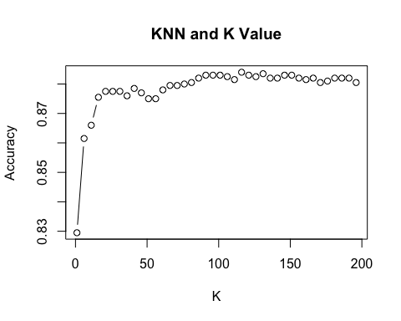

#b)  
output_1b <- data.frame(K = k_vals, Train_Error = numeric(length(k_vals)),   
 Test_Error = numeric(length(k_vals)))  
  
#c)  
opt_index <- which.min(output_1b$Test_Error)  
opt_K <- output_1b$K[opt_index]  
opt_train_error <- output_1b$Train_Error[opt_index]  
opt_test_error <- output_1b$Test_Error[opt_index]  
  
#d)  
x_min <- min(x_training[,1]) - 1  
x_max <- max(x_training[,1]) + 1  
y_min <- min(x_training[,2]) - 1  
y_max <- max(x_training[,2]) + 1  
grid <- expand.grid(seq(x_min, x_max, length.out = 200), seq(y_min, y_max, length.out = 200))  
colnames(grid) <- colnames(x_training)[1:2]  
  
grid_pred <- knn(train = x_training, test = grid, cl = y_training, k = opt_K)  
grid_pred_df <- data.frame(grid, Class = grid_pred)  
  
ggplot() +  
 geom_point(data = as.data.frame(x_training),   
 aes(x = x_training[, 1], y = x_training[, 2], color = y_training), size = 3) +  
 geom_tile(data = grid_pred_df,   
 aes(x = x.1, y = x.2, fill = Class), alpha = 0.2) +  
 labs(title = paste("Decision Boundary with K"),  
 x = "x.1", y = "x.2")

 